Softball Bats not compliant with the 52 COR/275 Compression Ball and 1.20 bpf Bat List

Any other Titanium or Senior Association Bat not listed on this sheet is also illegal

Combat Original da Bomb Senior (COMBAT-ANA) Combat Original da Bomb Senior (COMBAT-ANAE10)

Combat Senior Gear (SEN-GR) Demarini Geezer Senior (DXDGR-8)

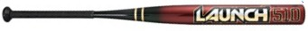
Worth Launch 510 Senior (WSRSB) 2009 Worth Launch 510 Senior (WSRRH)

Rip-It Senior (RESR2) Miken Ultra-II Maxload Senior (MSU2M)

Miken Ultra-II Legacy Senior (MSU2L) Miken Ultra-II Advanced (MSU2A)

Miken Ultra (Balanced & Maxload) Miken Ultra-II (MSU2)

Boombah Cannon Easton Titanium Typhoon (STI1)

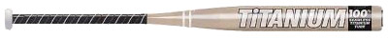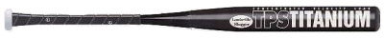
Worth Titanium (Ti51) Louisville Slugger TPS Titanium

Toloso Maximus Titanium Toloso Primo Titanium

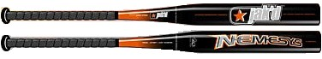
Jak’d Nemesys Composite (Canadian Bat)

